Rotation Around a Boundary Line

Definition
# Source: AI Source: Provided by: [Data Path: Persons Table -> ID Column: 1, Name_En Column: Motasem Essam] -> From: [ChatGPT] on [7/25/2026]
Rotation Around a Boundary Line is a method of generating a three-dimensional solid by rotating a plane region through a complete revolution (360°) around a straight line that coincides with one of the region's boundary lines.
The boundary line acts as the Axis of Revolution.
When the region touches the axis along a boundary segment, the generated solid generally has no central hole. Its cross-sections perpendicular to the axis are disks.
Characteristics:
- The axis of revolution coincides with a boundary line of the generating region.
- The region rotates through 360° around the axis.
- The axis forms part of the boundary of the original plane region.
- The generated solid generally has disk-shaped cross-sections.
- The resulting solid depends on the shape of the generating region and its dimensions.

Geometric Representation
# Source: AI Source: Provided by: [Data Path: Persons Table -> ID Column: 1, Name_En Column: Motasem Essam] -> From: [ChatGPT] on [7/25/2026]
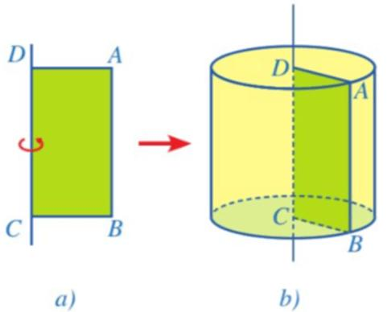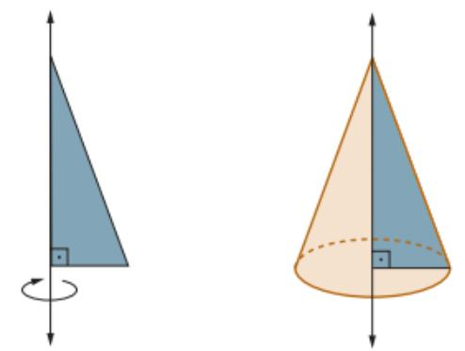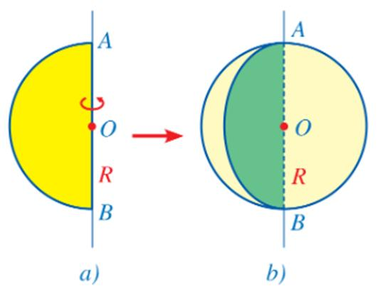

Geometric Structure
# Source: AI Source: Provided by: [Data Path: Persons Table -> ID Column: 1, Name_En Column: Motasem Essam] -> From: [ChatGPT] on [7/25/2026]
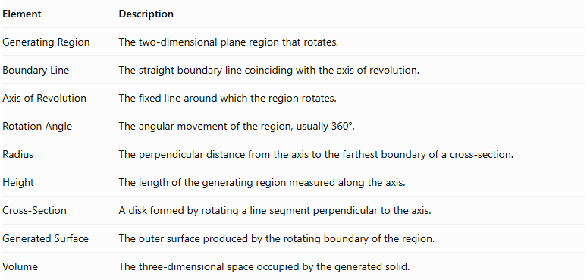
Element | Description
Generating Region | The two-dimensional plane region that rotates.
Boundary Line | The straight boundary line coinciding with the axis of revolution.
Axis of Revolution | The fixed line around which the region rotates.
Rotation Angle | The angular movement of the region, usually 360°.
Radius | The perpendicular distance from the axis to the farthest boundary of a cross-section.
Height | The length of the generating region measured along the axis.
Cross-Section | A disk formed by rotating a line segment perpendicular to the axis.
Generated Surface | The outer surface produced by the rotating boundary of the region.
Volume | The three-dimensional space occupied by the generated solid.

Types According to the Generating Region
# Source: AI Source: Provided by: [Data Path: Persons Table -> ID Column: 1, Name_En Column: Motasem Essam] -> From: [ChatGPT] on [7/25/2026]
The resulting solid depends on the geometric shape of the region and the boundary line chosen as the axis.

Rectangular-Region Rotation
# Source: AI Source: Provided by: [Data Path: Persons Table -> ID Column: 1, Name_En Column: Motasem Essam] -> From: [ChatGPT] on [7/25/2026]
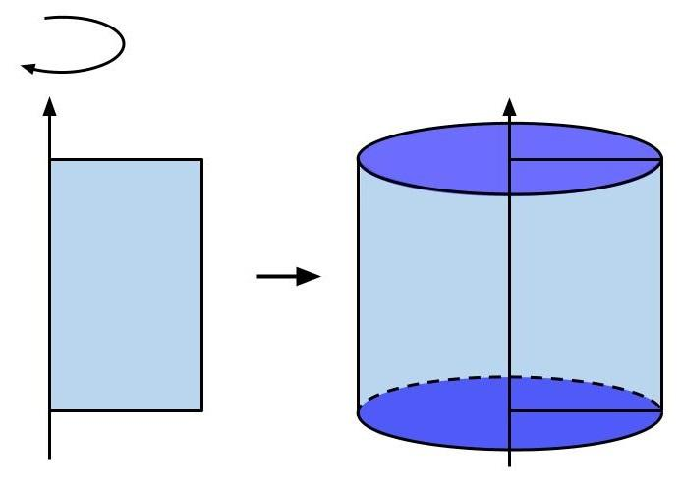
A rectangular region is rotated around one of its sides.
Generated Solid: Right Circular Cylinder.
Characteristics:
- The axis coincides with one side of the rectangle.
- The opposite side traces a cylindrical lateral surface.
- The other two sides generate the circular bases.
- The cylinder has a constant radius and height.
Mathematical properties:
$$V=πr^{2}h$$
$$A_{L}=2πrh$$
$$A_{T}=2πr(r+h)$$
Where:
- $r$ = cylinder radius.
- $h$ = cylinder height.

Triangular-Region Rotation
# Source: AI Source: Provided by: [Data Path: Persons Table -> ID Column: 1, Name_En Column: Motasem Essam] -> From: [ChatGPT] on [7/25/2026]
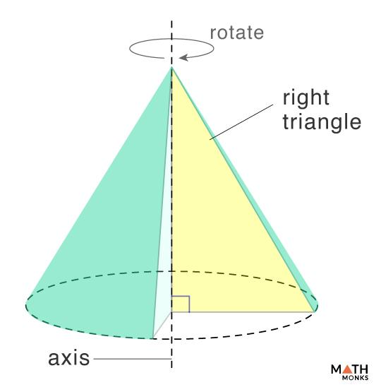
A right-triangular region is rotated around one of its perpendicular legs.
Generated Solid: Right Circular Cone.
Characteristics:
- The axis coincides with one perpendicular leg.
- The other perpendicular leg generates the circular base.
- The hypotenuse traces the conical lateral surface.
- The cone has one vertex and one circular base.
Mathematical properties:
$$V=\frac{1}{3}πr^{2}h$$
$$A_{L}=πrl$$
$$A_{T}=πr(l+r)$$
Where:
- $r$ = base radius.
- $h$ = cone height.
- $l$ = slant height.

Semicircular-Region Rotation
# Source: AI Source: Provided by: [Data Path: Persons Table -> ID Column: 1, Name_En Column: Motasem Essam] -> From: [ChatGPT] on [7/25/2026]
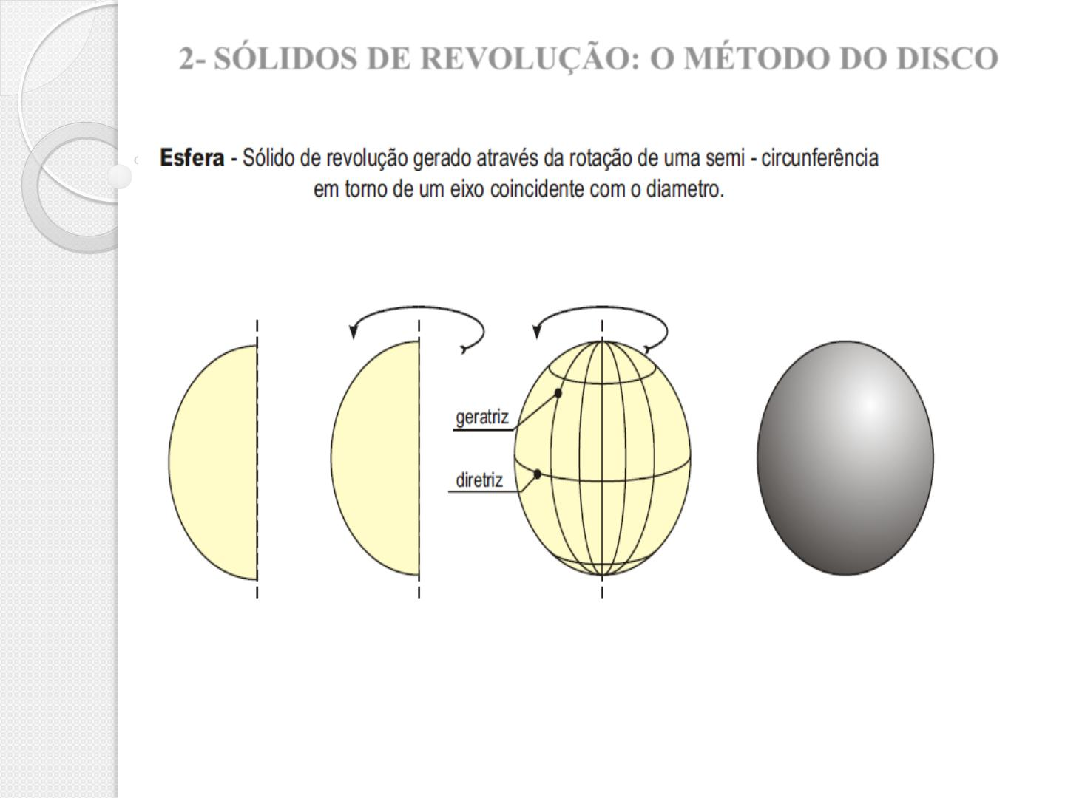
A semicircular region is rotated around its diameter.
Generated Solid: Sphere.
Characteristics:
- The axis coincides with the diameter of the semicircular region.
- The curved semicircular boundary generates the spherical surface.
- The entire filled region generates a solid sphere.
- Every central cross-section is a circle.
Mathematical properties:
$$V=\frac{4}{3}πR^{3}$$
$$A=4πR^{2}$$
Where $R$ is the sphere radius.

Circular-Sector Rotation
# Source: AI Source: Provided by: [Data Path: Persons Table -> ID Column: 1, Name_En Column: Motasem Essam] -> From: [ChatGPT] on [7/25/2026]
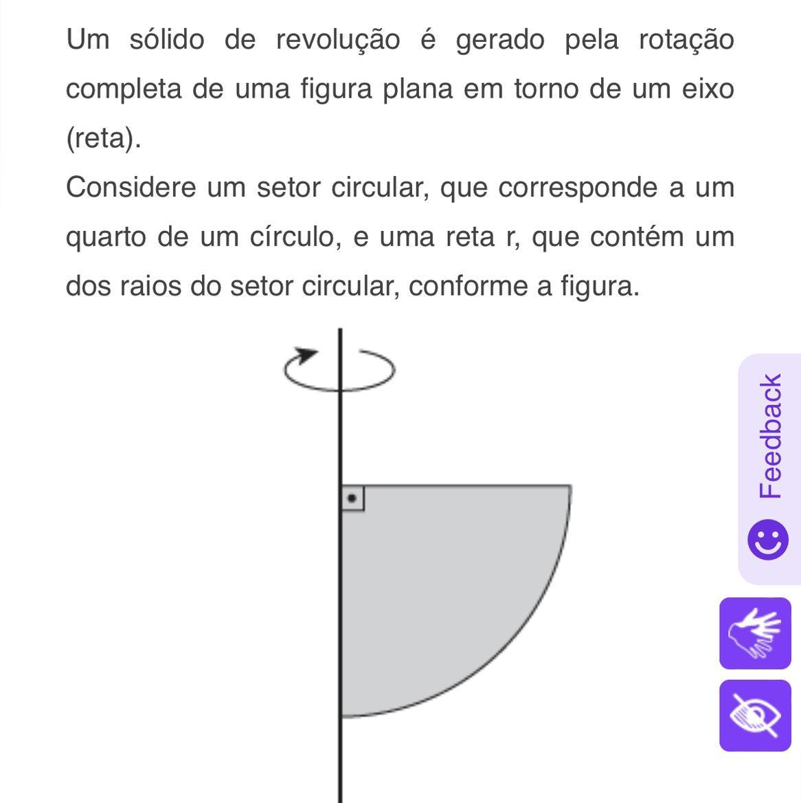
A circular-sector region is rotated around one of its bounding radii.
Generated Solid: A spherical-sector-type solid.
Characteristics:
- The axis coincides with one bounding radius.
- The curved arc generates a spherical surface portion.
- The radial boundaries sweep out conical surfaces or degenerate surfaces, depending on the sector.
- The resulting volume is a portion of a sphere.
For a sector with central angle $θ$, where $0<θ≤π$, rotating the sector about one bounding radius produces a spherical wedge whose solid angle is $2θ$.
Its volume is:
$$V=\frac{2θR^{3}}{3}$$
Where:
- $R$ = radius of the generating sector.
- $θ$ = central angle in radians.
Note: This is a spherical wedge, not necessarily the same as every geometric definition of a spherical sector.

General Mathematical Representation

Disk Method
# Source: AI Source: Provided by: [Data Path: Persons Table -> ID Column: 1, Name_En Column: Motasem Essam] -> From: [ChatGPT] on [7/25/2026]
When a plane region is rotated around a boundary line, a typical perpendicular line segment extending from the axis to the opposite boundary generates a circular disk.
The volume is calculated using:
$$\boxed{V=π\int_{a}^{b}{[R(x)]^{2} dx}}$$
Where:
- $R(x)$ = distance from the axis to the opposite boundary.
- $a,b$ = limits along the axis of revolution.
For a vertical axis, the corresponding formula is:
$$V=π\int_{c}^{d}{[R(y)]^{2} dy}$$

Surface Area of Revolution
# Source: AI Source: Provided by: [Data Path: Persons Table -> ID Column: 1, Name_En Column: Motasem Essam] -> From: [ChatGPT] on [7/25/2026]
For a curve $y=f(x)$ rotated around the $x$-axis:
$$\boxed{A=2π\int_{a}^{b}{f(x)\sqrt{1+[f'(x)]^{2}}} dx}$$
This formula applies when the curve lies on one side of the axis and generates the external surface.

Pappus's Centroid Theorem
# Source: AI Source: Provided by: [Data Path: Persons Table -> ID Column: 1, Name_En Column: Motasem Essam] -> From: [ChatGPT] on [7/25/2026]
For a plane region rotated around an axis in its plane that does not pass through its interior, the volume can also be calculated using:
$$\boxed{V=2πdA}$$
Where:
- $A$ = area of the generating region.
- $d$ = distance traveled by the region's centroid during one complete revolution.
Since the centroid travels a circumference of $2πd$:
$$V=A(2πd)$$
This theorem is useful when the centroid and generating-region area are known.

Mathematical Properties
# Source: AI Source: Provided by: [Data Path: Persons Table -> ID Column: 1, Name_En Column: Motasem Essam] -> From: [ChatGPT] on [7/25/2026]
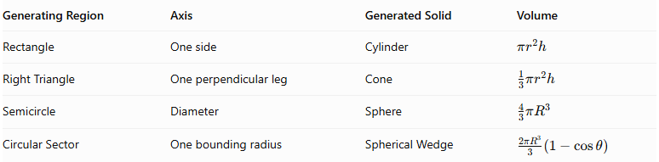
Generating Region | Axis | Generated Solid | Volume
Rectangle | One side | Cylinder | $$πr^{2}h$$
Right Triangle | One perpendicular leg | Cone | $$\frac{1}{3}πr^{2}h$$
Semicircle | Diameter | Sphere | $$\frac{4}{3}πR^{3}$$
Circular Sector | One bounding radius | Spherical Wedge | $$\frac{2πR^{3}}{3}(1-cosθ)$$
Correction for the circular-sector case: The spherical wedge volume formula uses the central angle $θ$ in radians.

Geometric Characteristics of the Generated Solids
# Source: AI Source: Provided by: [Data Path: Persons Table -> ID Column: 1, Name_En Column: Motasem Essam] -> From: [ChatGPT] on [7/25/2026]
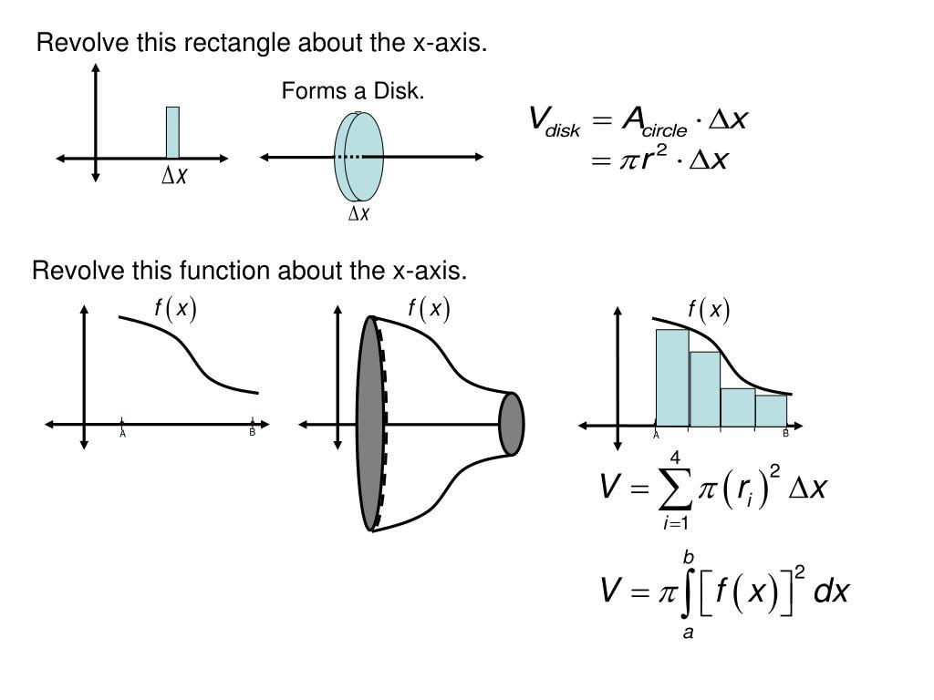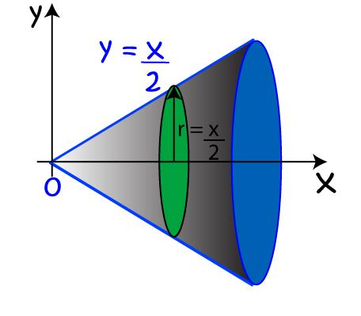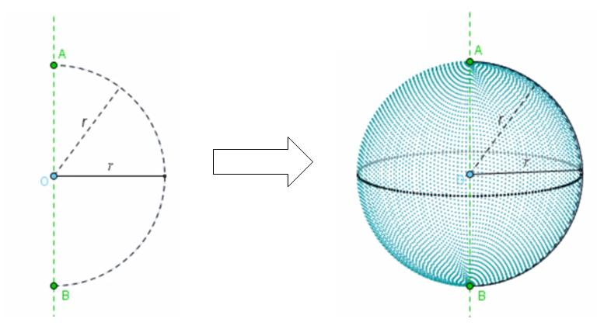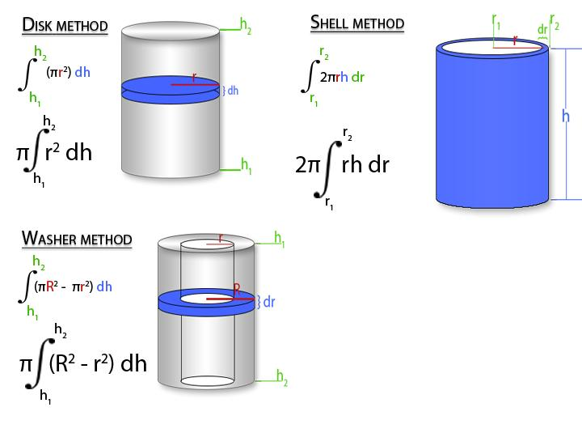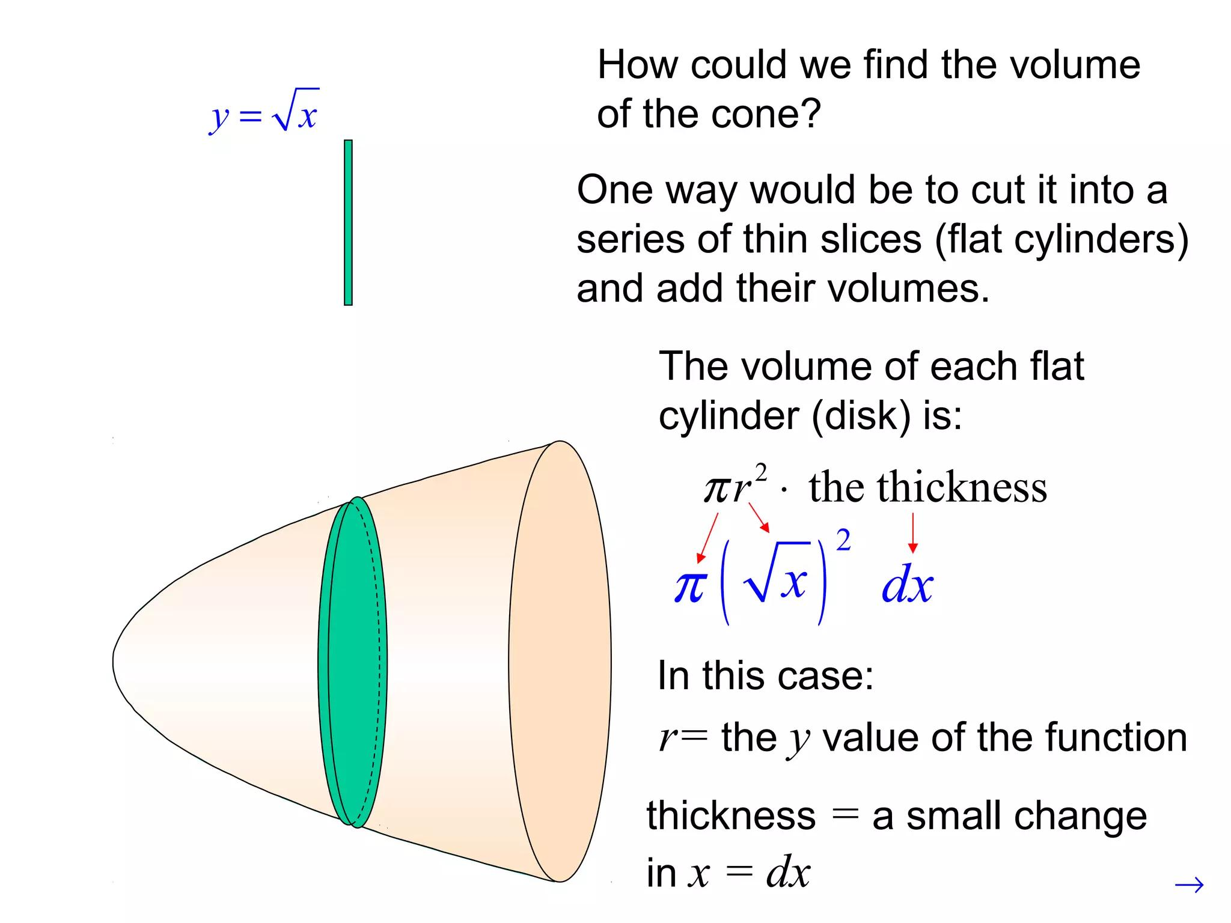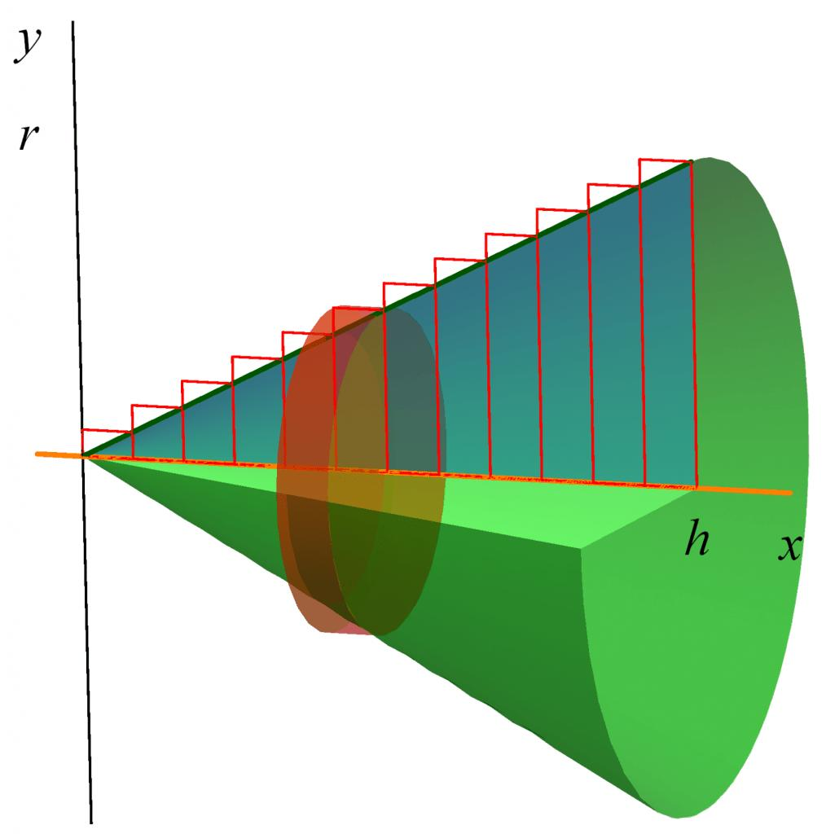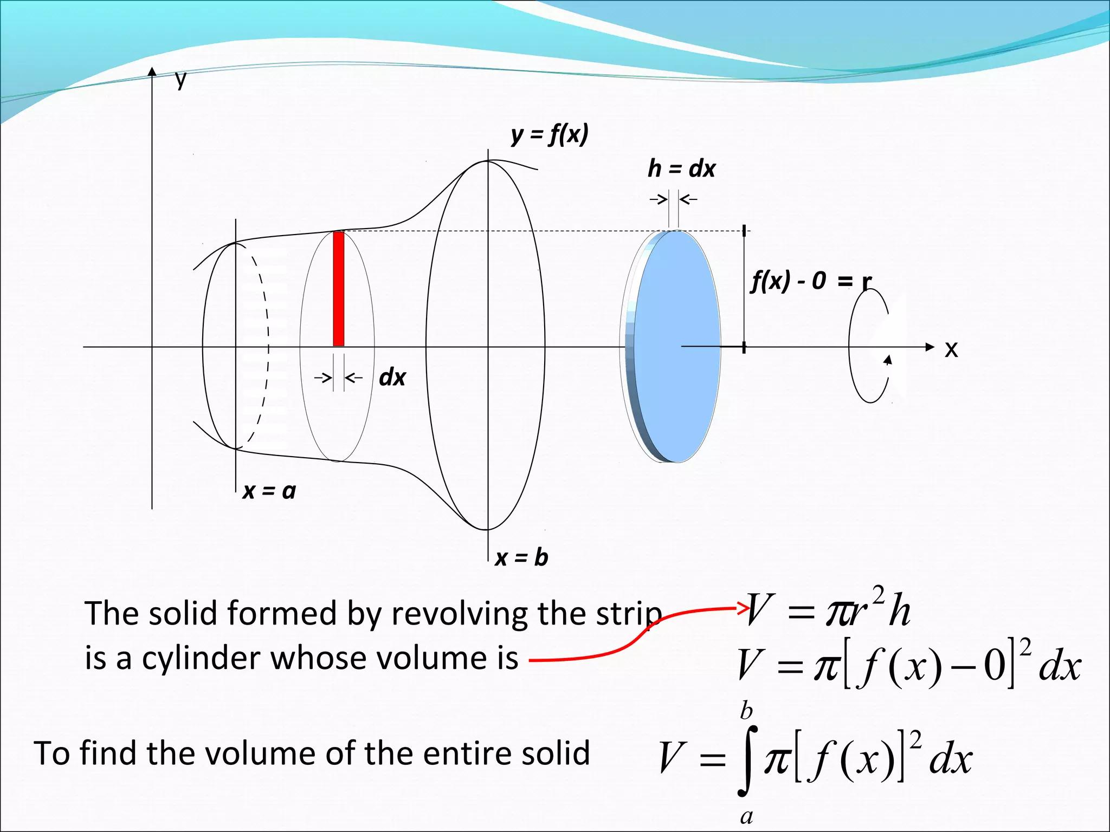
When the generating region is rotated around a boundary line:
- Disk Cross-Sections: Perpendicular slices generally produce filled circular disks.
- No Central Hole: When the generating region extends continuously from the axis to its opposite boundary, the resulting perpendicular cross-sections are disks rather than annular washers.
- Boundary Surface: The boundary of the generating region creates the external surface of the resulting solid.
- Axis of Symmetry: The generated solid is rotationally symmetric around the axis of revolution.

Applications
# Source: AI Source: Provided by: [Data Path: Persons Table -> ID Column: 1, Name_En Column: Motasem Essam] -> From: [ChatGPT] on [7/25/2026]
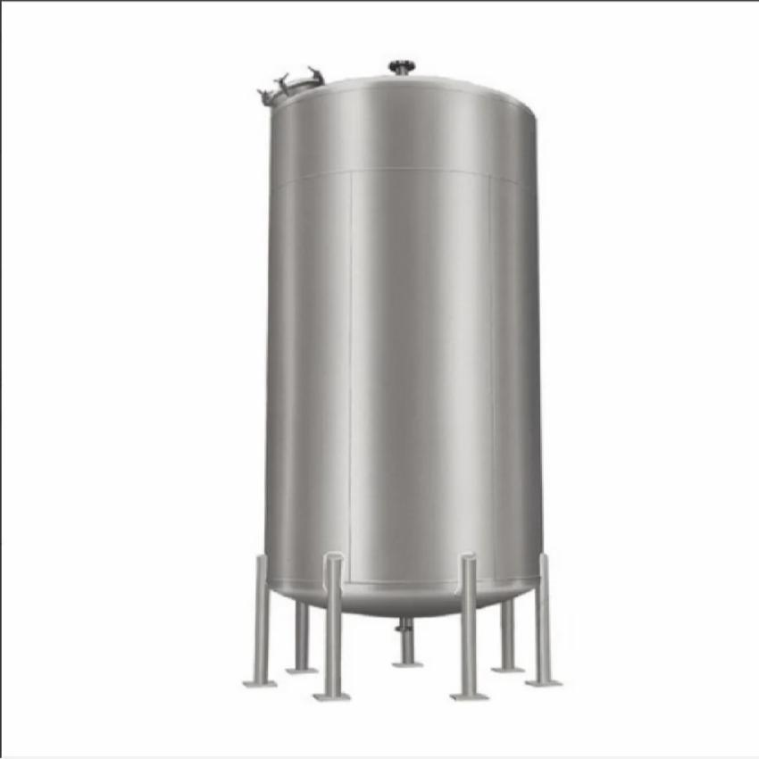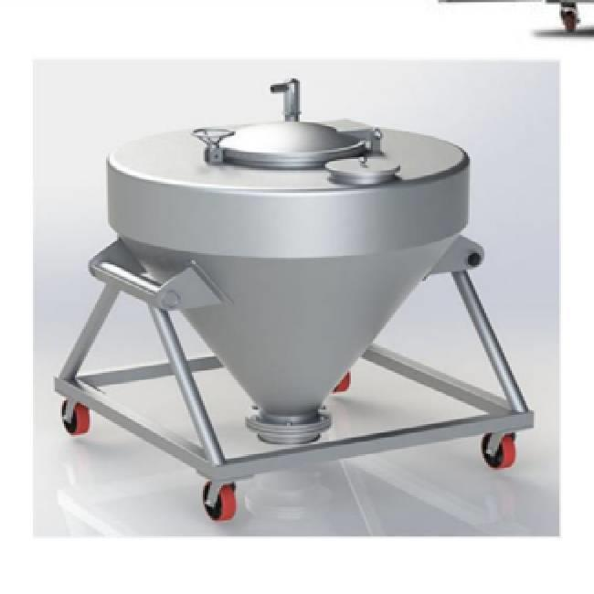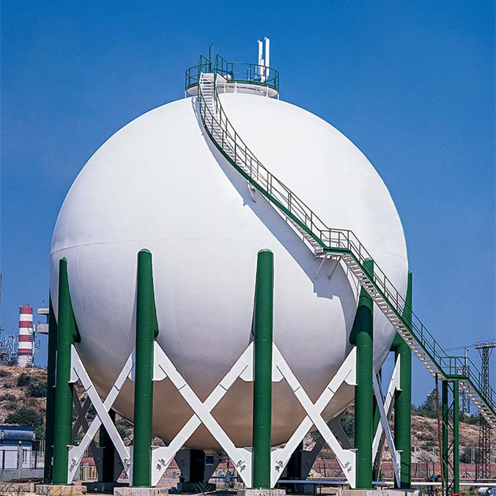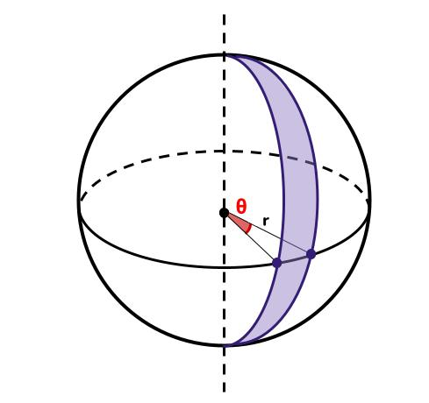
- Manufacturing: Producing cylindrical and conical components through turning operations.
- Architecture: Designing cylindrical columns, conical roofs, and spherical structures.
- Industrial Engineering: Creating tanks, containers, and pressure vessels.
- Mechanical Engineering: Manufacturing rotationally symmetric parts.
- Mathematics: Calculating volumes and surface areas using integration and geometric theorems.

Comparison with Other Axis Positions
# Source: AI Source: Provided by: [Data Path: Persons Table -> ID Column: 1, Name_En Column: Motasem Essam] -> From: [ChatGPT] on [7/25/2026]
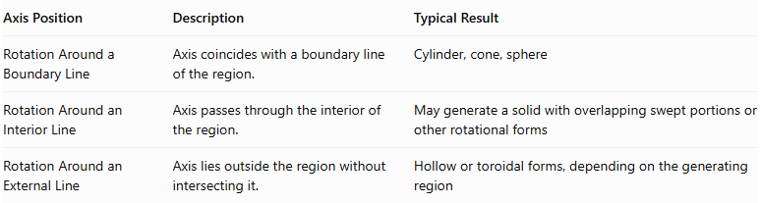
Axis Position | Description | Typical Result
Rotation Around a Boundary Line | Axis coincides with a boundary line of the region. | Cylinder, cone, sphere
Rotation Around an Interior Line | Axis passes through the interior of the region. | May generate a solid with overlapping swept portions or other rotational forms
Rotation Around an External Line | Axis lies outside the region without intersecting it. | Hollow or toroidal forms, depending on the generating region

Main Classification
# Source: AI Source: Provided by: [Data Path: Persons Table -> ID Column: 1, Name_En Column: Motasem Essam] -> From: [ChatGPT] on [7/25/2026]
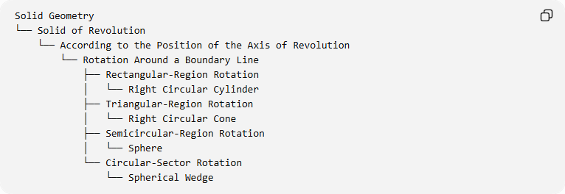
Solid Geometry
└── Solid of Revolution
└── According to the Position of the Axis of Revolution
└── Rotation Around a Boundary Line
├── Rectangular-Region Rotation
│ └── Right Circular Cylinder
├── Triangular-Region Rotation
│ └── Right Circular Cone
├── Semicircular-Region Rotation
│ └── Sphere
└── Circular-Sector Rotation
└── Spherical Wedge

Key Points
# Source: AI Source: Provided by: [Data Path: Persons Table -> ID Column: 1, Name_En Column: Motasem Essam] -> From: [ChatGPT] on [7/25/2026]
- Rotation around a boundary line occurs when the axis of revolution coincides with a straight boundary line of the generating region.
- The generating region completes a full 360° rotation.
- The resulting perpendicular cross-sections are generally filled disks.
- A rectangle rotated around one side generates a cylinder.
- A right triangle rotated around one perpendicular leg generates a cone.
- A semicircle rotated around its diameter generates a sphere.
- A circular sector rotated around one bounding radius generates a spherical wedge.
- The disk method and Pappus's centroid theorem can be used to calculate volumes.

Conclusion
# Source: AI Source: Provided by: [Data Path: Persons Table -> ID Column: 1, Name_En Column: Motasem Essam] -> From: [ChatGPT] on [7/25/2026]
Rotation Around a Boundary Line is a fundamental method of generating solids of revolution in which a plane region rotates around a straight line coinciding with one of its boundaries. The resulting solid depends on the shape of the generating region and the selected boundary line.
Common examples include cylinders generated from rectangular regions, cones generated from right-triangular regions, spheres generated from semicircular regions, and spherical wedges generated from circular sectors.
This classification is important in solid geometry because it explains how familiar three-dimensional solids can be constructed from two-dimensional plane regions through rotation. It also provides a foundation for calculating their volumes and surface areas using geometric formulas, integration, and Pappus's centroid theorem.

